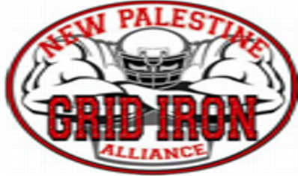

* Lunch Sponsor **$1,500**
* Touchdown **$500**
* Field Goal **$250**
* First Down **$150**

Phone: 1-317-220-0552

Email: newpalgridiron@gmail.com

**BENEFITING The New Pal Grid Iron Alliance**

8AM

Completed Form and Check Are Due by July 11, 2021.

Donation $______

Sponsorship(s) $______

Dragon Package: $___40_PER TEAM__

Mulligans (4 per golfer for 16 total); Ruler; Item for 1 golfer to play from

ladies tees all day.

Grand Total $______

Make Checks payable to NPGIA. Mail form with check to

NPGIA PO Box 614 New Palestine, IN 46163

Registration fees include:

green fee, cart fee, dinner, range balls,

and chances to win GREAT prizes!

$75

$300

Check the sponsorship(s) of

your choice:

2021 Dragon Classic

• Longest Drive

• Closest to Pin

• Par 3 Challenge

• 50/50

Sponsorships

Sunday, July 25, 2021

Hawks Tail

145 S. Morristown Pike

Greenfield, IN 46140

9 AM